*

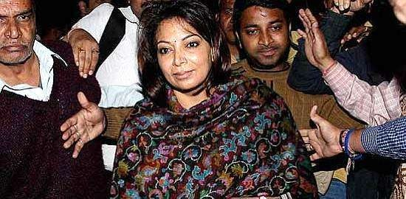

*



* The **2G Spectrum Scandal** involved officials in the government of India illegally undercharging mobile telephone companies for frequency allocation licenses, which they would use to create 2G subscriptions for cell phones.
* The shortfall between the money collected & the money which the law mandated to be collected is estimated to be **1.76 lakh crore** (1.763 trillion) rupees (roughly equivalent to 39 billion US dollars) based on 3G auction prices. The issuing of licenses occurred in 2008, but the scam came to public notice when the Indian Income Tax Department was investigating political lobbyist **Nira Radia**.
* The government's investigation & reactions to the findings were the subject of debate, as were the nature of the Indian media's reactions. The discussion around the reactions to the 2G spectrum scam became known in the media as the **Nira Radia Tapes Controversy**.
* Much of the credit of bringing this whole scam into the public light (by pursuing it in the court of law) goes to **Subramanian Swamy** who is the chief petitioner for this case in the court of law.
* Also there is a **national security angle** where Telenor & Etisalat was allowed to operate in India even after severe objections from the **Ministry of Home Affairs.**

## *



### Politicians involved:

* 1. A. Raja - Minister of Communications and Information Technology
  2. M. K. Kanimozhi - Rajya Sabha MP
  3. P. Chidambaram - Minister of Home Affairs

### Bureaucrats involved:

1. Siddharth Behura - Former Telecom Secretary
2. R. K. Chandolia - Raja's private secretary

### Corporate Executives involved:

1. Gautam Doshi - Managing Director of Reliance Anil Dhirubhai Ambani Group
2. Surendra Pipara - Vice-President of Anil Dhirubhai Ambani Group & Reliance Telecom
3. Hari Nair - senior vice-president of Anil Dhirubhai Ambani Group
4. Sanjay Chandra - Managing Director of Unitech Wireless (Tamil Nadu) Ltd
5. Shahid Balwa - Swan Telecom promoter
6. Vinod Goenka - Swan Telecom promoter
7. Sharath Kumar - Managing Director of Kalaignar TV
8. Rajiv Agarwal & Asif Balwa - Chief Executives of Kusegaon Fruits &

Vegetable

* **Film and Entertainment persons involved:**
  1. Karim Morani - Cineyug Media and Entertainment Ltd‘s Director
* **Corporations accused:**

1. Unitech
2. Swan Telecom
3. Videocon Telecommunications Limited
4. S Tel
5. Reliance Communications

* **Businessmen accused:**

1. Ratan Tata – Chairman of Tata Sons
2. Anil Ambani – Chairman of Reliance Telecommunications

* **Journalists accused:**

1. Barkha Dutt - Group editor, English news, NDTV
2. M.K. Venu - senior business journalist
3. Vir Sanghvi - a Hindustan Times editor
4. Prabhu Chawla - editor of India Today magazine
5. Shankar Aiyar - then with India Today Group

* **Media persons accused:**

1) Nira Radia - a corporate lobbyist whose conversations with politicians and corporate entities were recorded by the government and leaked, creating

the Nira Radia Tapes Controversy

# *

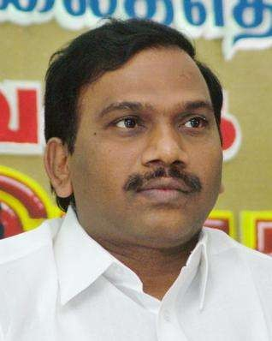

* The **2G spectrum financial scandal** in the Telecommunications and IT Ministry under

A. Raja is noteworthy as the largest political corruption case in modern Indian history.

* The alleged **modus operandi** was telecom bandwidth being grossly undervalued and offered to a chosen few with vested interests, on a dubious 'First-Come-First-Served' basis. It is alleged that it should have been put under a transparent auction system, purportedly advised by higher office.
* The financial scam eventually led to Raja's **resignation** on the 14th of November, 2010. There will be further criminal

investigation and action on Raja with reports being filed by the Comptroller & Auditor General (CAG) and the Central Bureau of Investigation (CBI).

* On February 2, 2011, the **CBI arrested Raja**. The CBI also arrested R. K. Chandolia, Raja's personal aide, and Siddharth Behura, the former Telecom Secretary. Both Raja and R. K. Chandolia are heard in conversation with Nira Radia in the released Radia tapes.

## *

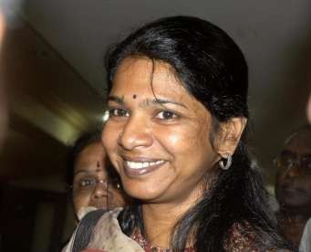

* In November 2010 Outlook published **transcripts of six conversations** between lobbyist Nira Radia and Kanimozhi from May 2009. India Today claims that these conversations reveal that Kanimozhi filtered the information flowing to her father (the Chief Minister of Tamil Nadu) and thereby "tipped the scales in favour of" A. Raja.
* Following the **Income Tax Department's raid** on Tamil Maiyam, an NGO of which she is a director, Kanimozhi said the DMK party will come out clean in the CBI probe, stating ―The law has to take its own course. It is a process to prove us not guilty‖.
* On May 20, 2011, the special Central Bureau of Investigation (CBI) court in New Delhi ordered the arrest of Kanimozhi along with Kalaignar TV CEO

Sharad Kumar after rejecting their bail pleas. Kanimozhi was **arrested** and sent to Tihar Jail.

* Kanimozhi appealed for bail but it got rejected considering the enormity of the crime commited which is likely to affect the economy of the country. On Nov 28, 2011, Kanimozhi was **granted bail** by the Delhi high court in the 2G case.

# *



* Unitech Wireless, charged in the 2G telecom spectrum scam, on Monday defended itself in the trial court, arguing there was **no evidence** to suggest it had influenced the controversial change in the cut-off date for license

applications in 2007 to September 25.

* The company‘s counsel, S. S. Gandhi, said the allegation that the **cut-off date was changed** so that no other company could apply for licenses after Unitech did was

factually incorrect. Applications for around 40 licenses were made on September 25, a

day after Unitech applied, he said.

* Unitech got into a joint venture with Norway's **Telenor** to bring in funds for setting up the infrastructure, Gandhi said. ―All investment from Telenor got approval from the Foreign Investment Promotion Board and the Cabinet Committee on Economic Affairs,‖ said Gandhi.

# *



* Swan Telecom on Friday sought its discharge from the 2G case by claiming in a Delhi court that it **cannot be held a co-conspirator** with former Telecom Minister A Raja as besides it, many firms, including Tata Teleservices and Datacom, were also ready with demand drafts of Rs. 1659 crore to get licenses.
* "There is **nothing sinister** in CBI's allegations that only Swan Telecom had a prior knowledge about the requirement of a DD of Rs. 1659 crore to get the 2G licenses. Many companies such as Tata, Idea Cellular, Spice and Unitech were also ready with the drafts on January 10, 2008.―
* The real estate tycoon-turned-telecom czar told the court that it was in March 2007 that Raja got a report from the Wireless Planning and Coordination wing (WPC) saying **no spectrum was available** in Delhi circle.
* "In November 2007, however, **all of a**

### sudden 15 MHz spectrum appeared in Delhi

circle and nobody knew how did it appear," he said, adding that as per the DoT website, even today 12 MHz Spectrum is available in the Delhi circle.

*

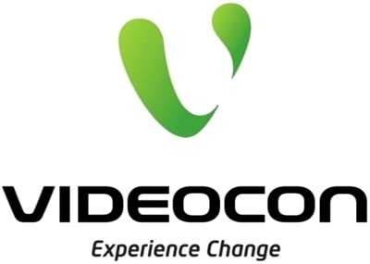

* + The Central Bureau of Investigation (CBI) on Monday questioned promoters of the Videocon group, **Venugopal Dhoot and his brother and Rajya Sabha member Rajkumar Dhoot**, over their alleged links with the so-called second-generation (2G) spectrum allocation scam.
  + India‘s top investigating agency, which has also interrogated Reliance Group Chairman, Anil Ambani and Essar Group chief executive

Prashant Ruia in the alleged scandal, **quizzed the Dhoot brothers** until late in the evening at its headquarters in New Delhi, a CBI official said on condition of anonymity.

* + The brothers were questioned about the shareholding pattern of **Datacom Solutions Pvt. Ltd**, which was

awarded 21 licences during spectrum allocation in 2008, the official said.

* + Datacom was initially owned by Himachal Futuristic Communications Ltd (HFCL), but was renamed Videocon Telecommunications Ltd after the owners sold an equity stake to the Videocon group. It is now jointly owned by the Dhoots and HFCL promoter Mahendra Nahata. **Videocon group owns a 64% stake in Datacom** and the rest is held by Nahata.

* **S Tel**



* + S Tel Private Limited (S Tel) is a joint venture between **Siva Group** (formerly Sterling Infotech Group) (51%) and **Bahrain Telecommunications Company** (Batelco) (49%). It is to be noted that S Tel Private Limited was the Company which got spectrum during former telecom minister A. Raja's tenure is owned by Mr. Sivasankaran.
  + The Central Bureau of Investigation (CBI) is looking into the **security related issues** regarding S Tel and DB Group as part of its probe into the 2G telecom spectrum scam, the agency told the Joint Parliamentary

Committee (JPC) earlier this week. This was one of the many points made in CBI‘s 47-

page presentation to the JPC.

* + The investigative agency is also looking at the **alleged breach of security** by the Dynamix Balwas (DB) Group-held airplanes, the CBI told the the JPC. Eon Aviation, a subsidiary of the DB Group, has also been under the scanner over security concerns. While CBI officials did not elaborate on the matter, the agency is learnt to have taken up the matter in the light of the Foreign Investment Promotion Board's (FIPB) observation a few years ago.

# *

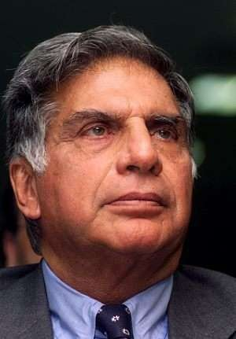

* Tata first has been shown as a victim of DMK leader, A. Raja in the CBI first charge sheet. Surprisingly, in the same charge sheet, CBI estimated loss of **Rs. 8,448.95 crores** to the exchequer from Tata‘s dual technology licenses. Tata not only got 19 dual technology licenses but also got 3 new licenses in 2008 at 2001 price for which loss to the exchequer is estimated **to Rs .22,535.6 crores**.
* Till recently, two senior DMK leaders (P. V. Kalyanasundaram &

V. R. S. Sampath) were helping Tata by acting as director in Tata Communications. A. Raja considered Tata applications for dual technology licenses even though these applications were filed after last date. It shows, **Tata was the biggest beneficiary of A. Raja policies** and major contributor of loss to the exchequer claimed by CBI in its charge sheet.

* **Tata’s hand-written letter** of November 13, 2007 (delivered personally through Nira Radia) to the then Tamil Nadu Chief Minister praising A. Raja‘s action defies the CBI story of Tata as

victim. In this letter, Tata had complained about some ‗powerful vested interest groups‘ in the telecom industry but Tata had forgotten that he is also part of the same class.

# *

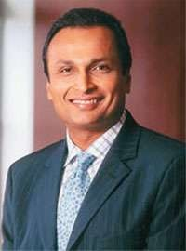

* Anil Ambani, chairman of the Anil Dhirubhai Ambani Group (ADAG), is now a suspect in the 2G scam.The investigators are not satisfied with his responses during the questioning session in the CBI headquarters on Wednesday.
* As part of the CBI plan to question the bosses of all the companies that got UAS licences during former telecom minister A Raja's regime, the agency called Prashant Ruia, CEO and MD of Essar group, on Thursday.
* When Ambani was brought face-to-face with Raja and Balwa during Wednesday's questioning, he claimed that his group had exited Swan Telecom when it got the UAS licence on January 10, 2008.
* The sources also disclosed that Ambani was asked more than 50 questions on Wednesday on the shareholding pattern since the incorporation of Swan Capital — later renamed Swan Telecom — and the ownership transfer of the company to Balwa and Goenka.

# *

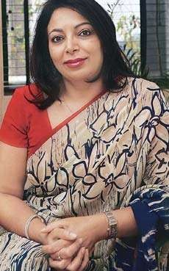

* After getting authorization from the Home Ministry, the Indian Income Tax department tapped Radia's phone lines for 300 days in 2008-2009

as part of their investigations into possible money laundering, restricted financial practices, and tax evasion.

* In November 2010, OPEN magazine carried a story which reported transcripts of some of the telephone conversations of Nira Radia with senior journalists, politicians, and corporate houses, many of whom have denied the allegations.
* The Central Bureau of Investigation has announced that they have 5,851 recordings of phone conversations by Radia, some of which outline Radia's attempts to broker deals in relation to the 2G spectrum sale.
* The tapes appear to demonstrate how Radia attempted to use some media persons to influence the decision to appoint A. Raja as telecom minister.

# *

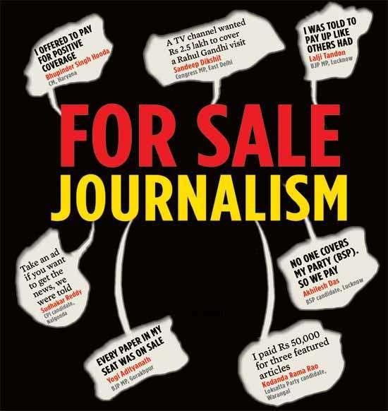

* + The news gained prominence following sustained pressure on social networking sites Twitter and Facebook against an attempted blackout orchestrated by many prominent Indian TV channels and newspapers.
  + Initially, only a handful of the mainstream newspapers in India, like The Deccan Herald,Indian Express had openly written about the tapes. Some newspapers like HT Media, Mint and NDTV said "the authenticity of these transcripts cannot be ascertained".
  + CNN-IBN‘s Sagarika Ghose discussed with a panel of experts, if the corporate lobbying is undermining democracy, on the Face the Nation programme on the channel. The Radia tapes is seen to have also made a dent in the image of the media in the country.
  + "The complete blackout of the Nira Radia tapes by the entire broadcast media and most of the major English newspapers paints a truer picture of corruption in the country," wrote G Sampath, the deputy editor of the Daily News and Analysis (DNA) newspaper. After it became an international news, more and more media houses covered the story.
  + The largest circulated english newspaper in the India and the world, The Times of India finally opened up on November 25, 2010, commenting "The people are showing who the boss is. The weapon in their hands is the internet, ... has seen frantic activism against "power brokering" by journalists in collusion with corporate groups and top government politicians...‖



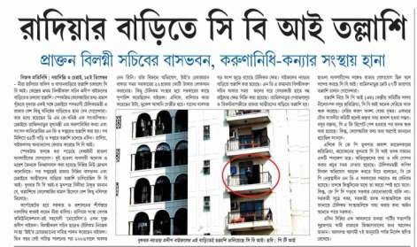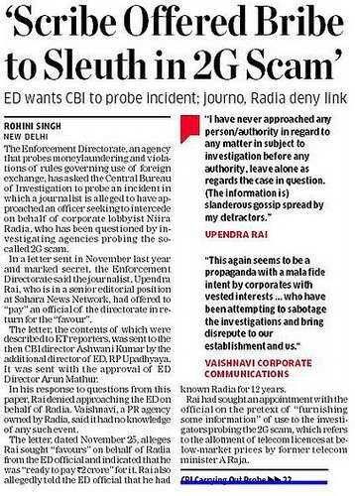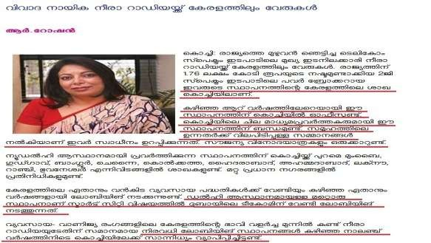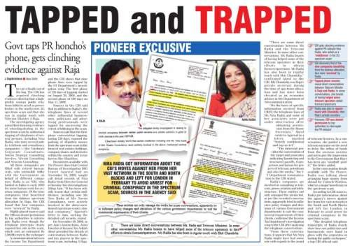

# *



* + It was the media who should have exposed the big people involved in the scam. It was their responsibility to be transparent and impartial to the society.
  + When it comes to the issue of National Security, the media had the onus of creating awareness about the scam and the different parties involved.
  + The media should be treating Tata as an equally responsible & accountable participant in the scam which has cheated honest tax-payers & the government of India of their money.
  + In spite of the benevolent nature of the Tata Group or the global appeal of the Ambanis, none of them should be treated by the media as anything other than frauds.
  + As for the media strategy of the Tatas, they should be promoting & marketing all their forays into the public welfare domain. As for the telecommunication part of their group, they should just focus on providing better service & increased levels of maintenance.





# *